LAB 6

**1.** Design a database diagram for a product orders database with four tables. Indicate the relationships between tables and identify the primary key and foreign key in each table. Explain your design decisions.

Customers (CustomerID, CustomerName, Address, Email, Phone)

Orders (OrderID, CustomerID, OrderDate, ShipDate, Price)

OrderItem (OrderID, ProductID, Quantity, UnitPrice)

Products (ProductID, ProductName, Price, InStock, OnOrder)

**Comment:**

* All the four tables in the product order database contains several columns as per the requirement.
* Out of which, CustomerID, ProductID, Quantity and ProductID columns of Customers, Orders, OrderItem, and Products serves as a Primary Key.
* Additionally, CustomerID, OrderID, and ProductID serves as the Foreign Key in the Orders and OrderItem tables which makes it easy to retrieve the data of order history of the customers.
* Here, One to Many relationship is present between Customers and Orders table as well as Orders, OrderItem and Products Table.

**Output:**

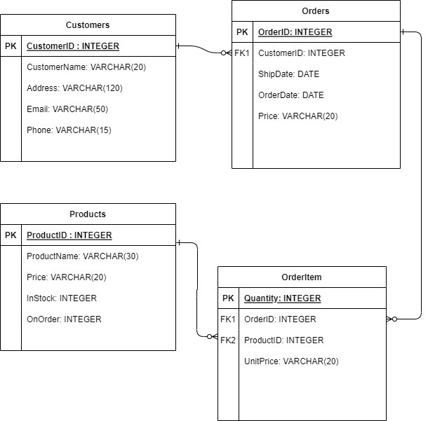

**2.** Add the two tables below into the design for question 1. Create additional tables and columns if necessary. Explain your design decisions. Shipping (ShippingID, OrderID, ShipperName, ShipperPhone, Weight, ShippingDate, ShippingMedium)Employees (EmployeeID, SSN, FirstName, LastName, DepartmentName, HireDate, HomeAddress, Phone, Email)

**Comments:**

* All the four tables in the product order database contains several columns as per the requirement.
* Out of which, CustomerID, ProductID, Quantity, ShippingID, EmployeeID and ProductID columns of Customers, Orders, OrderItem, Shipping, Employees and Products serves as a Primary Key.
* Additionally, CustomerID and EmployeeID, OrderID and ProductID, OrderID serves as the Foreign Key in the Orders, OrderItem, Shipping tables respectively which makes it easy to retrieve the data of order history of the customers.
* Here, One to Many relationship is present between Customers and Orders table as well as Orders, OrderItem and Products Table, between Orders and Shipping table, Employees and Orders table.

**Output:**

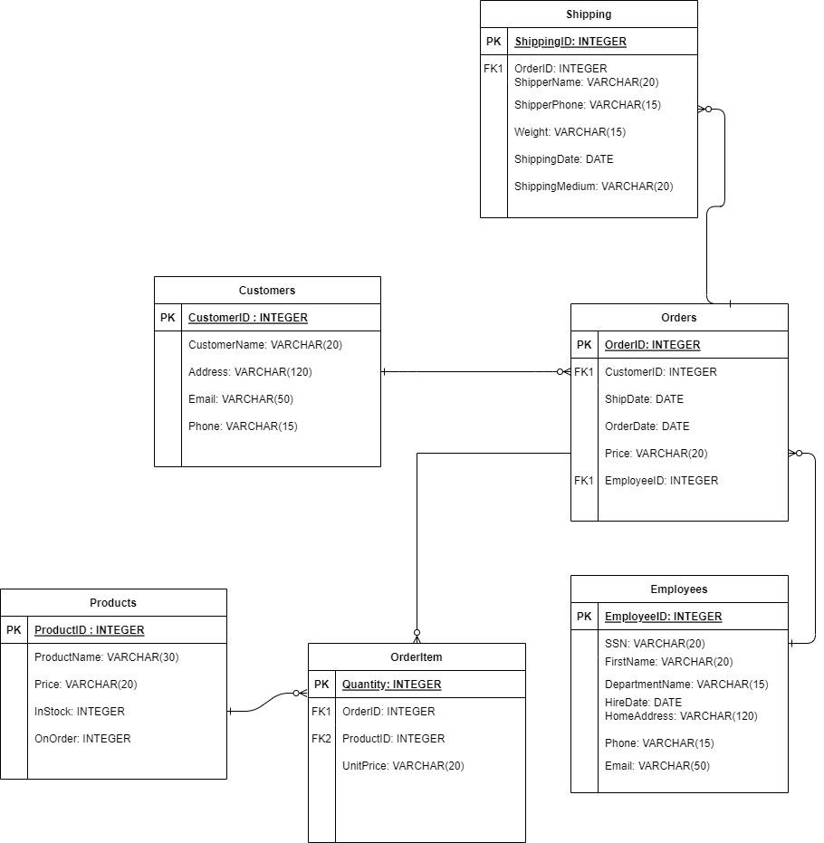

**3.** Design a database diagram that allows students to be assigned study-group membership for one or more courses. Each course can have any number of students and each student can be in any number of courses. Create additional tables and columns, if necessary. Indicate the relationships between tables and identify the primary key and foreign key in each table. Explain your decisions.

**Comment:**

* In the below database design, three tables are created namely, Students, StudyGroup and Courses.
* Students table consists 5 columns to store the basic details of the students like their first name, ast name, email, phone and studentId, where studentID behaves as a primary key.
* Courses table consists of all the courses with their courname and courseId, where courseID is a primary key.
* A table called StudyGroup is created which refers to the students that are enrolled into the number of different courses by using the Foreing Keys i.e. StudentID from Student Table and CourseID from Coures Table.
* There is a one-to-many relationship between Student and StudyGroup Table as well as Courses and StudyGroup Table.
* Here, the StudyGroup table will act like a linking table which will link the students and their courses.

**Output:**

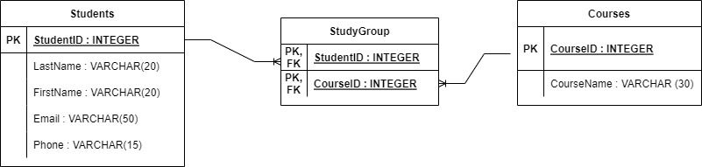

**4.** Modify your design for question 3 to keep track of the assignment for each student in each course. Each student can be given multiple assignments in each course. Each course has a unique set of assignments for the students to complete. Create additional tables and columns if necessary. Indicate the relationships between tables and identify the primary key and foreign key in each table. Explain your decisions.

**Comments:**

* Here a table called Assignments is added in the existing database design of students and the purses.
* AssignmentID, CourseID, GivenDate and DeadlineDate columns are added to the Assignment table.
* This table works as one-to-many relationship with the StudyGroup Table by behaving as a foreign key in that table and reflects the data about a student’s course enrollments and the assignments of those courses that the student needs to complete.
* CourseId from Curses Table behaves as the Forign Key in the Assingments table as it indicates the number of assignments present in each course.
* Courses Table and Assingments Table has one-to-many relationship.

**Output:**

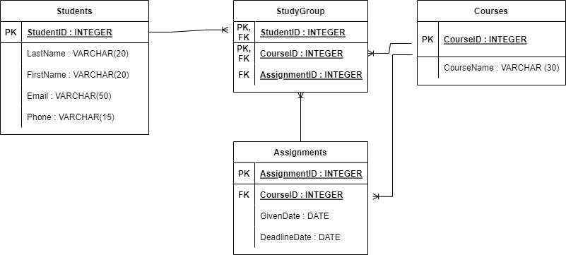

## Remarks for the Lab:

The overall lab consisted the designing of the databases.